

BSc (Hons) in Computer Science via GDSE

Module Code ITS1066

Professional Software Project in IT

NAME OF PROJECT

STUDENT NAME =G.Chamod Vishmina Kularathna

STUDENT ID = 252751066

BATCH NO =75

SUBMITTION DATE(19/11/2025)

Page 1 of 5

Content

No Title Page
1.0 Introduction to business 3
2.0 Overview of the proposed solution 4
3.0 Advantages of the solution 5
4.0 Use case diagram 6
5.0 Entity relationship diagram (ERD) 7

List of Figures

No Title Page

Figure 1.1 Employee Hierarchy 12

Page 2 of 5

List of Abbreviation

IJSE - Institute of Java & Software Engineering

IT - Information Technology

SE - Software Engineer

QAE - Quality Assurance Engineer

SD - Software Developer

BCS - British Computer Society

HR - Human Resource

Proposal content here

Introduction to business

The business is owned by mr.Sarath Gunarathna an experienced entrepreneur who has been managing the company for several years. He is managing his grocery smoothly.

The name of business is sarath super mart . The business has been continuing since 2007.This is a local business They sell grocery items and provide the best quality products to their customer . the business currently employee 5 staff members including the owner , cashiers, stock keepers and assistance . The owner supervises all employees , The cashier handles financial recodes and transactions . The stock keeper handle the store. The assistants arrange item on racks and help customers choose the products they need .

Overview of the proposed solution
Stock empty problem -> we can apply limiters for stock level . rech the level after notification the stock Alert .

want to check monthly sales-> we can save sell item quantity and details in the recodes.

Want to check daily profit -> we can sell item price – parchase price , its can check profits.

Advantages of the solutions

Prevents Stock-Outs and Overstocking →
By using stock level limiters and automatic alerts, the system notifies the owner when an item reaches the minimum level.

Accurate and Easy Sales Tracking →
Saving monthly sales data view total sales for any month and Identify bestselling items.

Clear and Quick Profit Calculation →
Storing both selling price and purchase price, the system can automatically calculate daily profit

Use case diagram

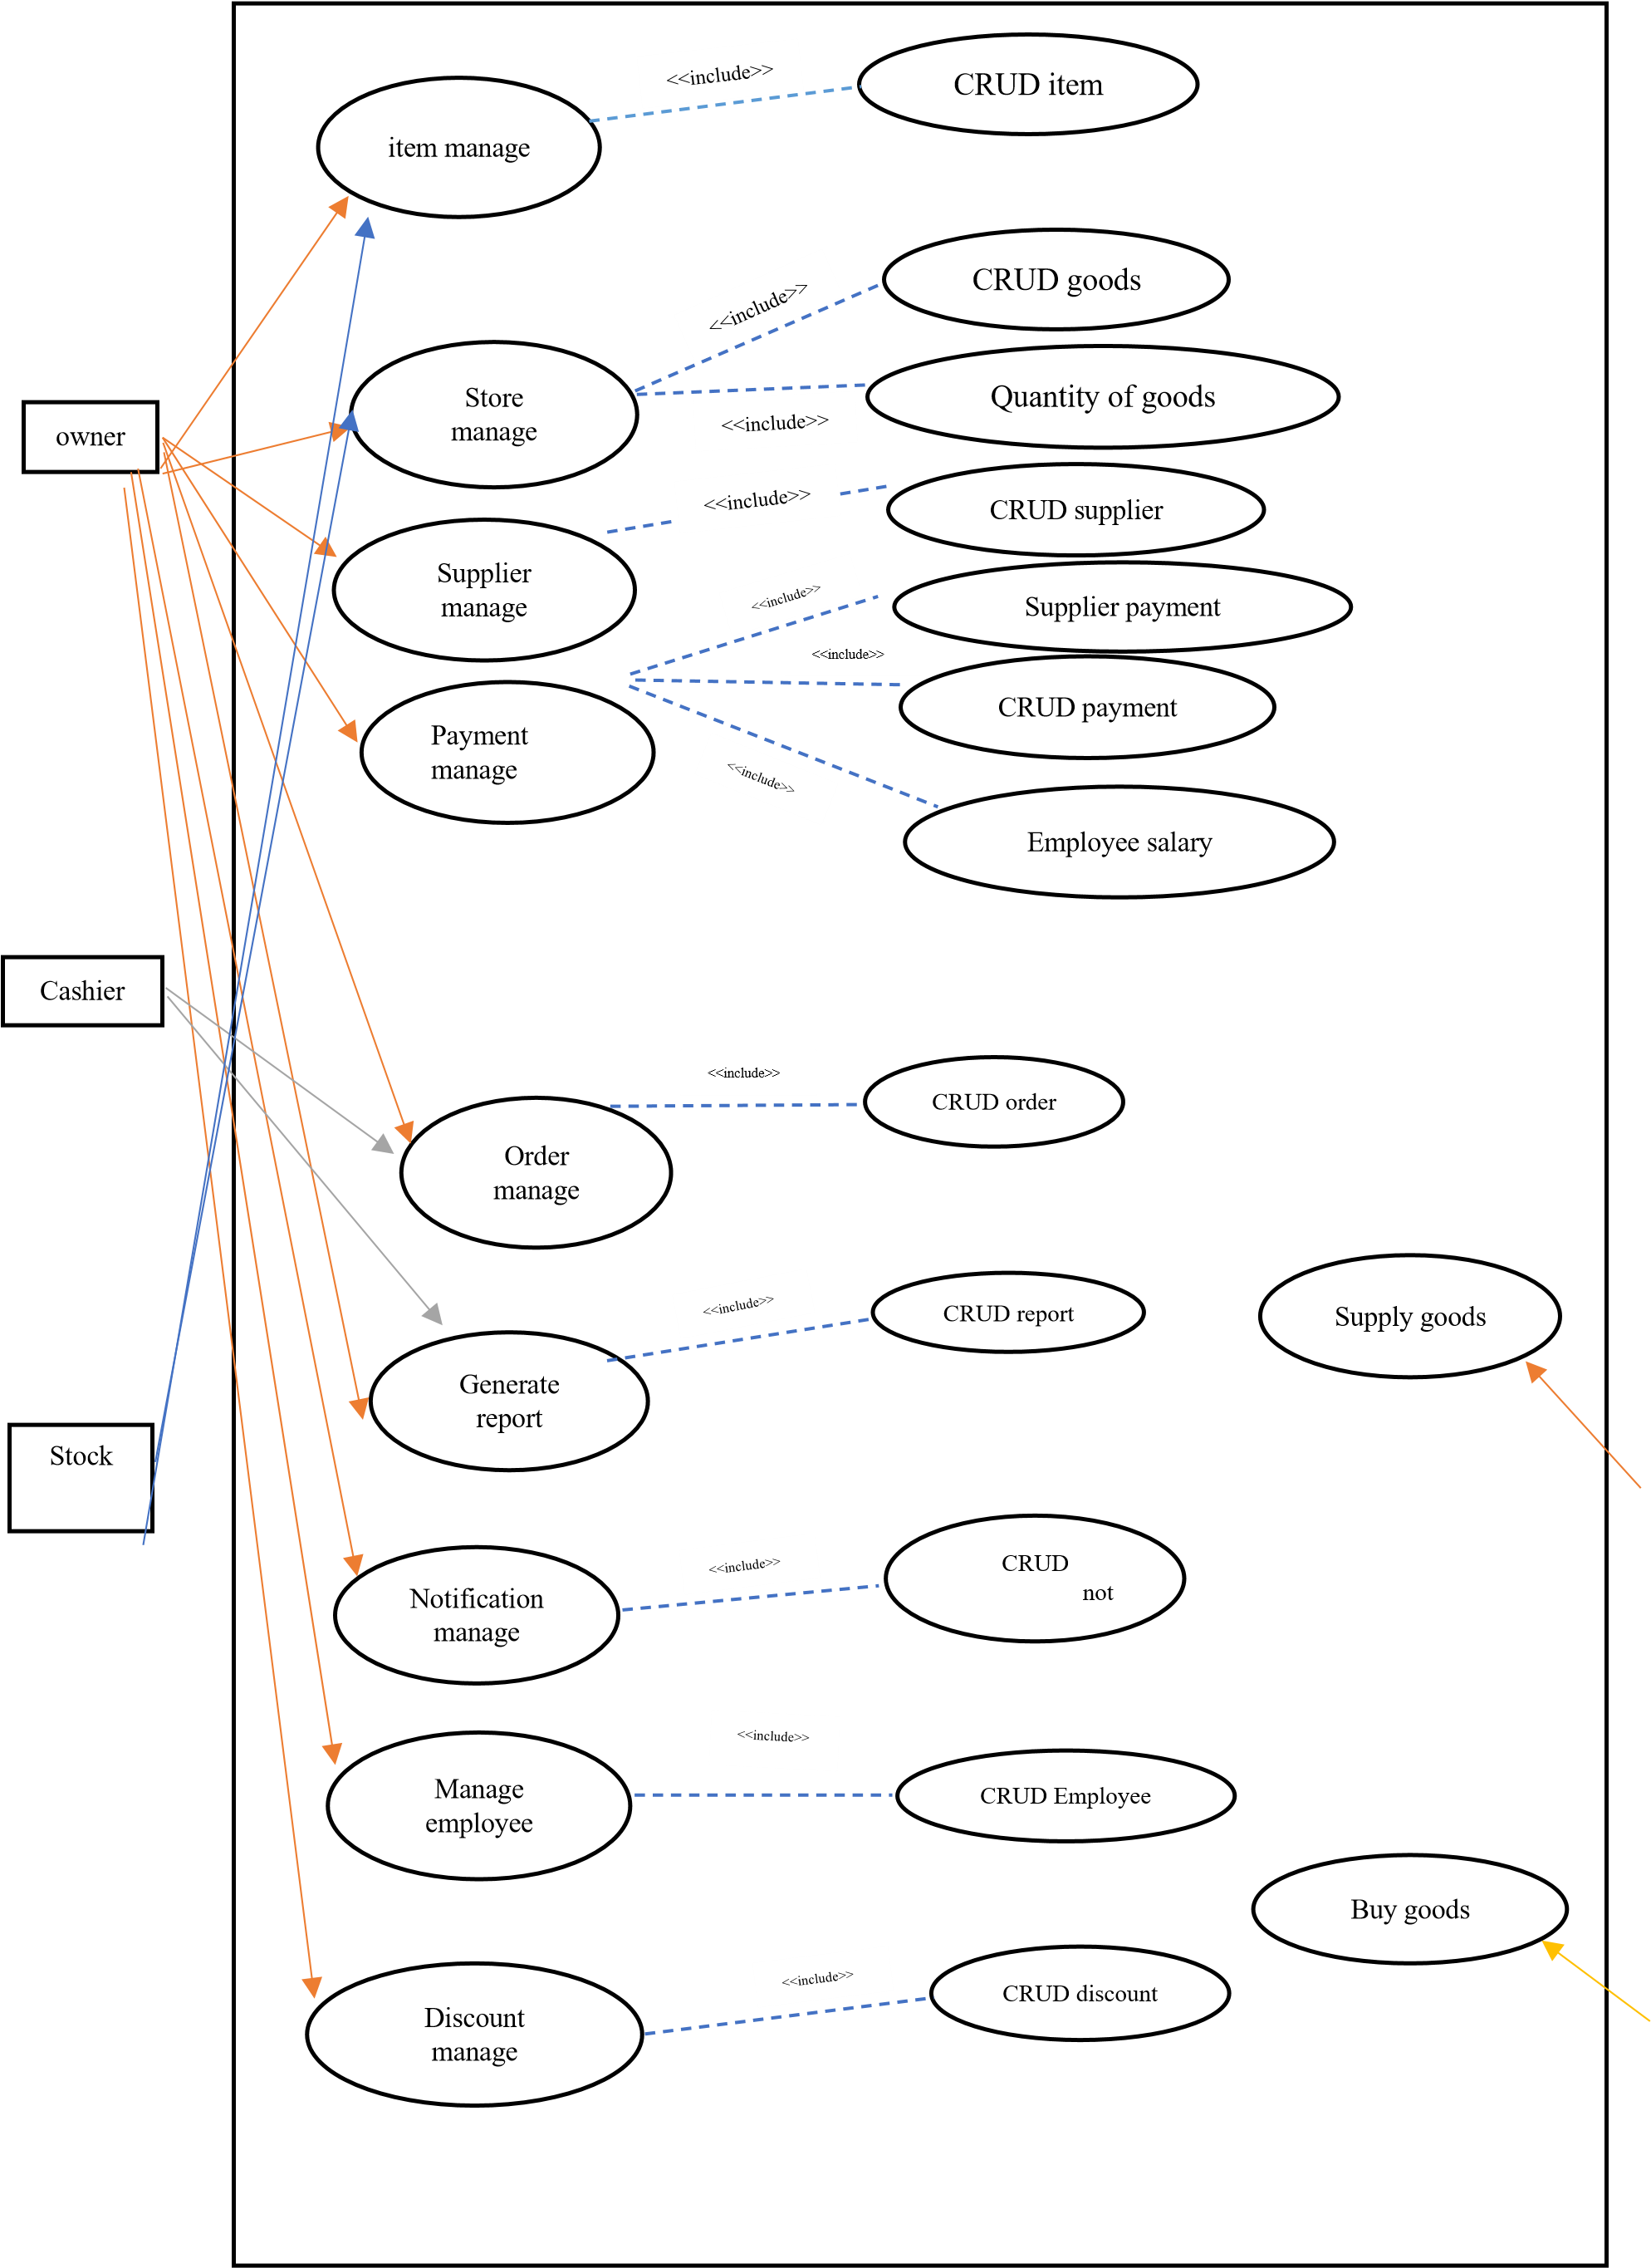 | customer  supplier

ER diagram
